**an opinion survey on**

**“GRADUATION 3rdYEAR COLLEGE sTUDENTS OF CALCUTTA UNIVERSITY REGARDING TEACHING QUALITY AND future working field PREFERENCE”**

**A PROJECT REPORT**

|  |  |
| --- | --- |
| **UNDER SUPERVISION OF:** | **SUBMITTED BY:** |
| **Mr. MUKUL BASU**  **(Techtree Technologies)**  **……………………………………………..**  Techtree-Logo-Transparent.png | **ARGHYA PAL**  **M.Sc 1st year**  **Department of Statistics**  **(Banaras Hindu University)** |

**CERTIFICATE**

This is to certify that the data given in this report has been collected, tabulated, analyzed and presented by “Mr. ARGHYA PAL” student of M.Sc (STATISTICS)- 2016-2018.

The title of project is “AN OPINION SURVEY ON GRADUATION 3rd YEAR COLLEGE STUDENTS OF CALCUTTA UNIVERSITY REGARDING TEACHING QUALITY AND FUTURE WORKING FIELD PREFERENCE ”.

|  |  |
| --- | --- |
| DATE: | Prof. Partha Pal HOD - Department Of Statistics  Maulana Azad College,Kolkata  …………………………………………….. |

**ACKNOWLEDGMENT**

It gives me immense pleasure to express my profound gratitude, gratefulness and indebtedness to reverend teacher and supervisor Prof. Partha Pal and Mr. Mukul Basu for their untiring help, constant encouragement, worthy supervision without which it would not have been possible for me to complete this project work. The guidance and valuable criticism that I received from them, during the entire period of this work, has been a great help in the completion of this work.

I offer my deep regards to Mukul Basu,Techtree Technologies ,who inspired and provided all requisite support towards the completion of this project work. I also express deep sense of gratitude to senior students of Department Of statistics for their valuable suggestions and hope they will continue their guidance in future also.

I also thanks to the student who co-operated me in Project Work Analysis. I also express my sincere thanks to some of my batchmates for his/her sincere co-operation.

|  |  |
| --- | --- |
|  |  |
| **Date:** | **ARGHYA PAL**  **M.Sc 1st year**  **Department of Statistics**  **Institute of Statistics**  **(Banaras Hindu University)** |

**CONCEPT OF CHI SQUARE TEST**

Chi-square test is applied to find out whether the two variables in a bivariate contingency table under the study are dependent or independent. Our two hypothesis; null hypothesis H0 and alternate hypothesisH1.

H 0 : The two attributes are independent

H1 : The two attributes are dependent

Computation is done using the formula:

χ2 = ∑∑(fij -eij)2 /eij ῀χ2 (r-1)(s-1)

where i=1, 2……r and j=1, 2…….. s

fij = observed frequency of (i,j)th cell

eij = expectedfrequency of (i,j)th cell and is given by

eij = (ni*nj)/N

where ni andnj are marginal totals and N is the total number of observation. The test statistic follows, under H 0 a chi-square distribution with (r-1)(s-1) degrees of freedom. The null hypothesis can be tested either at 5% or 1% level of significance, if

χ2cal<χ2 tab

then we may be accept H 0 which shows that the two variables are independent of each other otherwise we may be reject the H 0 which shows that the two variables are not independent i.e. dependent of each other . Also when the observed frequency is less than five, pooling is done to apply the test.

**CONTENTS**

* **INTRODUCTION**
* **METHODOLOGY OF SURVEY**

**1. PLANNING OF THE SURVEY**

1. **OBJECTIVES OF THE SURVEY**
2. **AREA OF SURVEY**
3. **SAMPLING TECHNIQUE**
4. **TECHNIQUE OF DATA COLLECTION**
5. **ANALYSIS AND REPORTING**
6. **DURATION OF SURVEY**

* **DATA ANALYSIS &INTERPRETATION**
* **CONCLUSION**
* **FIELD EXPERIENCE**
* **DIFFICULTIES**
* **LIMITATIONS**
* **QUESTIONNAIRE**
* **BIBLOGRAPHY**

**INTRODUCTION**



**METHODOLOGY OFSURVEY**

**METHODOLOGY OF SURVEY**

In any type of survey, preplanning and systematic approach play an important role to arrive at the best possible results and successful completion in minimum time and cost. Also the success of that depends upon resources, quality, timing and integrity of the surveyor who compiles the primary data so it is very important task to manage all the available resources which make an impact of the quality of the survey*.*

(1)PLANNING OF THE SURVEY: A full proof planning is an essential part of any statistical survey to complete it in a successful manner at minimum cost, labour and time. Planning of survey includes selection of topic and preparation of a short questionnaire covering almost all the area. From this questionnaire, I select those questions which seem to be relevant in context of the mentioned topic.

(2)OBJECTIVES OF THE SURVEY: A complete and well defined objective should be mentioned at the very beginning stage. The main objective of the survey is to know the view of respondents that what the general thinking about media is.

(3)AREA OF SURVEY: For performing any survey a sample is selected from a population. I decided to collect my sample from the graduation 3rd year college students of Calcutta university had a survey of total 200 respondents.

(4)SAMPLING TECHNIQUES: In statistics, population is an aggregate of objects, animate or inanimate, under study. The population will be finite or infinite. A sample is a finite subset of statistical individuals in a population and a number of individuals in a sample is called a sample size. It is the sample from which we can make inferences about the population in which we are interested.

(5)TECHNIQUE OF DATA COLLECTION: Raw data can be collected by various techniques. Data for this project was collected by means of questionnaire, which would be perhaps the best way. Since it helps person to study. Decide and filling up the questionnaire in a cool and easy manner without any pressure and bound. Questionnaire was filled by the respondents themselves. Questionnaire was explained to the respondents whenever required.

(6)ANALYSIS AND REPORTING: After collection of raw data we put them in coded form so that the analysis becomes easy. For this purpose, I use software named as Excel in which I fed my data. Then I analyze and interpret the data of using R programming language(Simpler and component bar diagram,pie diagram).

a)Simple Bar Diagram: - Simple Bar is a diagrammatical representation of the data. In this method bar of equal width are taken for the different items of the series. The length of the bar represents the value of the variable under consideration.

b) Component Bar Diagram: -Component Bar is a diagrammatical representation of the data. In this method bar of equal width are taken for the different items of the series and two or more than two components are combined together in one bar. The length of the bar represents the value of the variable under consideration.

c) Pie Diagam: - pie diagam is a diagrammatical representation of the data in a circle.A pie chart (or a circle chart) is a circular[*statistical graphic*](https://en.wikipedia.org/wiki/Statistical_graphics) which is divided into slices to illustrate numerical proportion. In a pie chart, the [arc length](https://en.wikipedia.org/wiki/Arc_length) of each slice (and consequently its [central angle](https://en.wikipedia.org/wiki/Central_angle) and [area](https://en.wikipedia.org/wiki/Area)), is [proportional](https://en.wikipedia.org/wiki/Proportionality_(mathematics)) to the quantity it represents.

(7)DURATION OF SURVEY:Keeping above prospective in a view a Questionnaire has been prepared by me under the supervision of Prof. Partha Pal and Mukul Basu. In the first week of February,2017 it was distributed to the respondents and in the last week of February,2017 it was finally collected by me.

**Research Design**

|  |  |
| --- | --- |
| Research Design | Descriptive research |
| Research Method | Survey method |
| Research Instrument | Structured questionnaire |
| Sample Size | 200 |
| Sample area | colleges under calcutta university |
| Sampling method | Non-Probablity/Convenience Sampling |
| Statistical package | R |
| Analytical tool | Percentage analysis,Angle,Chi Square,graphs |

**DATA ANALYSIS&INTERPRETATION**

**Tables &Graphs**

**۞TABLE 1: FREQUENCY TABLE & GRAPH REPRESENTING GENDER OF RESPONDENTS**

|  |  |  |
| --- | --- | --- |
| **Statistics** | | |
| N | Valid | 200 |
| Missing | 0 |

|  |  |  |  |  |  |  |
| --- | --- | --- | --- | --- | --- | --- |
| Gender | | Frequency | Percent | Valid Percent | Cumulative Percent | Angle |
| Valid | Male | 114 | 57.0 | 57.0 | 57.0 | 205.2 |
| Female | 86 | 43.0 | 43.0 | 100.0 | 154.8 |
|  | Total | 200 | 100.0 | 100.0 |  | 360.0 |

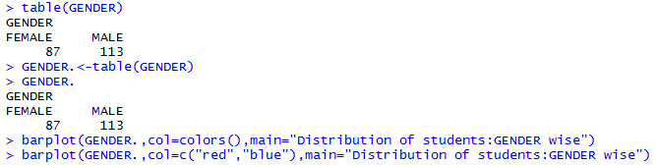

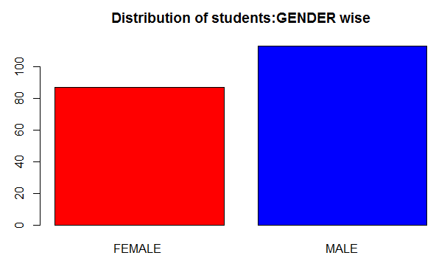

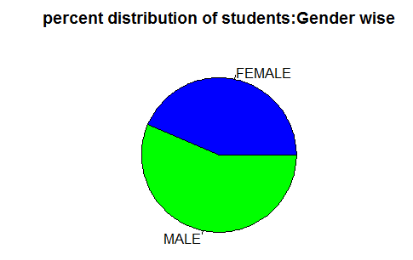



**Interpretation :-** From the above graph we observed that maximum(57.0 %) respondents are male and rest are female.

**۞ TABLE 2: FREQUENCY TABLE & GRAPH REPRESENTING PLACE OF RESIDENCEY OF THE RESPONDENTS.**

|  |  |  |
| --- | --- | --- |
| **Statistics** | | |
| N | Valid | 200 |
| Missing | 0 |

|  |  |  |  |  |  |  |
| --- | --- | --- | --- | --- | --- | --- |
| Residency | | Frequency | Percent | Valid Percent | Cumulative percent | Angle |
| Valid | Rural | 72 | 36.0 | 36.0 | 36.0 | 129.6 |
| Urban | 128 | 64.0 | 64.0 | 100.0 | 230.4 |
| Total | 200 | 100.0 | 100.0 |  | 360.0 |

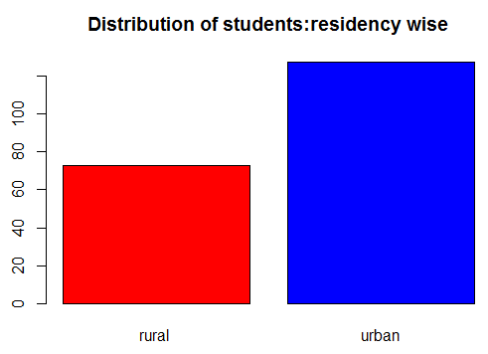

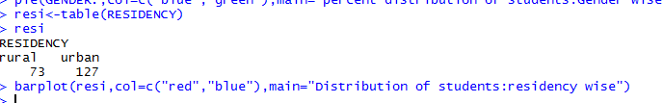



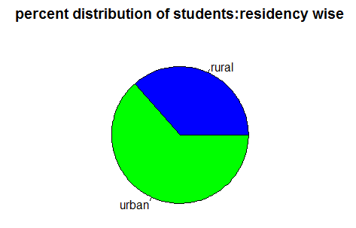

**Interpretation :-**Above graph show that maximum(64.0 %) respondents are belong to the Urban area and rest are belong to the Rural area.

**۞ TABLE 3: FREQUENCY TABLE & GRAPH REPRESENTING YEAR OF ENROLLMENT IN GRADUATION OF THE RESPONDENTS.**

|  |  |  |
| --- | --- | --- |
| **Statistics** | | |
| N | Valid | 200 |
| Missing | 0 |

|  |  |  |  |  |  |  |
| --- | --- | --- | --- | --- | --- | --- |
| Year | | Frequency | Percent | Valid Percent | Cumulative Percent | angle |
| Valid | 2012 | 16 | 8.0 | 8.0 | 8.0 | 28.8 |
| 2013 | 29 | 14.5 | 14.5 | 22.5 | 52.2 |
| 2014 | 155 | 77.5 | 77.5 | 100.0 | 279.0 |
| Total | 200 | 100.0 | 100.0 |  | 360.0 |

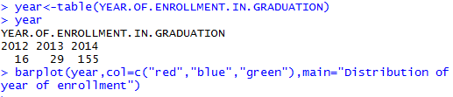

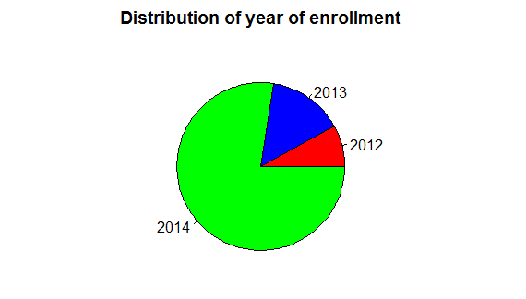



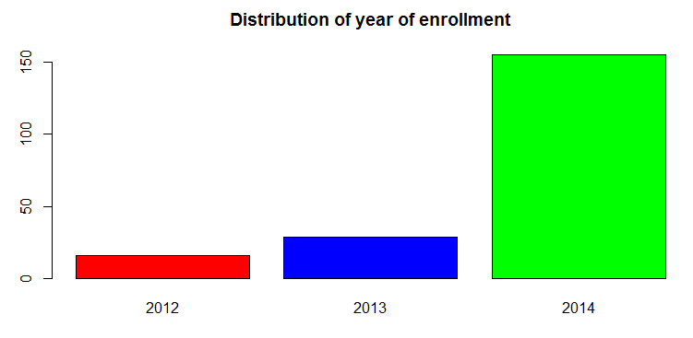

**Interpretation :-**From the above graph we see that 77.5 % respondents are enrolled in graduation on the year 2014 and 14.5 % are enrolled in graduation on the year 2013 and 8.0 % enrolled in graduation on the year 2012.

**۞ TABLE 4: FREQUENCY TABLE & GRAPH REPRESENTING HONOURS SUBJECT OF THE RESPONDENTS.**

|  |  |  |
| --- | --- | --- |
| **Statistics** | | |
| N | Valid | 200 |
| Missing | 0 |

|  |  |  |  |  |  |  |
| --- | --- | --- | --- | --- | --- | --- |
| Honours Subject | | Frequency | Percent | Valid Percent | Cumulative Percent | angle |
| Valid | Physics | 18 | 9.0 | 9.0 | 9.0 | 32.4 |
| Chemisty | 23 | 11.5 | 11.5 | 20.5 | 41.4 |
| Mathematics | 32 | 16.0 | 16.0 | 36.5 | 57.6 |
| Zoology | 19 | 9.5 | 9.5 | 46.0 | 34.2 |
| Botany | 28 | 14.0 | 14.0 | 60.0 | 50.4 |
| Computer Science | 13 | 6.5 | 6.5 | 66.5 | 23.4 |
| Statistics | 36 | 18.0 | 18.0 | 84.5 | 64.8 |
| Geography | 14 | 7.0 | 7.0 | 91.5 | 25.2 |
| Geology | 17 | 8.5 | 8.5 | 100.0 | 30.6 |
| Total | 200 | 100.0 | 100.0 |  | 360.0 |

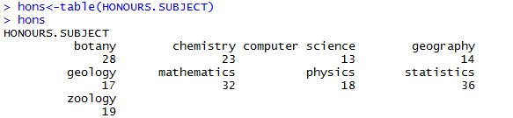



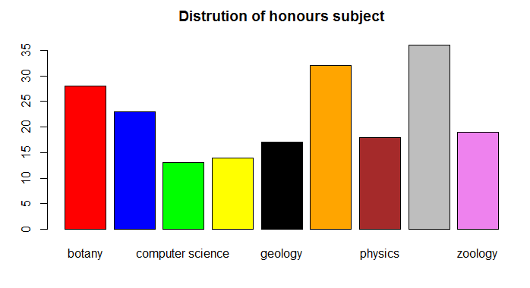

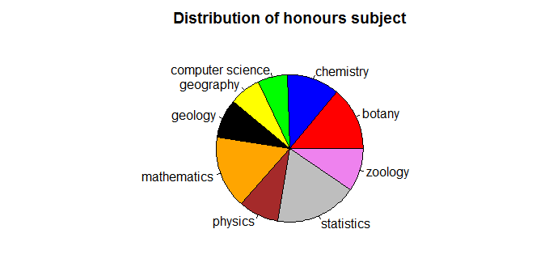



**Interpretation :-**From the above graph we see that maximum(18.5 %) respondents pursue the statistics Honours subject and minimum(6.5 % ) respondents pursue the computer science Honours subject and rest are lies between this range.

**۞ TABLE 5: FREQUENCY TABLE & GRAPH REPRESENTING FAMILY MONTHLY INCOME OF THE RESPONDENTS.**

|  |  |  |
| --- | --- | --- |
| **Statistics** | | |
| N | Valid | 194 |
| Missing | 6 |

|  |  |  |  |  |  |  |
| --- | --- | --- | --- | --- | --- | --- |
| Family monthly income | | Frequency | Percent | Valid Percent | Cumulative Percent | angle |
| Valid | 0-5000 | 24 | 12.0 | 12.4 | 12.4 | 44.64 |
| 5000-15000 | 65 | 32.5 | 33.5 | 45.9 | 120.6 |
| 15000-25000 | 84 | 42.0 | 43.3 | 89.2 | 155.88 |
| 25000-35000 | 5 | 2.5 | 2.6 | 91.8 | 9.36 |
| above 35000 | 16 | 8.0 | 8.2 | 100.0 | 29.52 |
| Total | 194 | 97.0 | 100.0 |  | 360.0 |
| Missing | System | 6 | 3.0 |  |  |  |
| Total | | 200 | 100.0 |  |  |  |

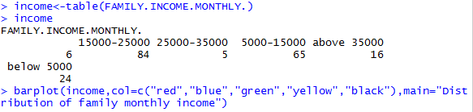

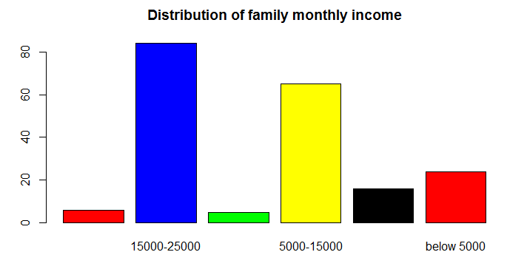



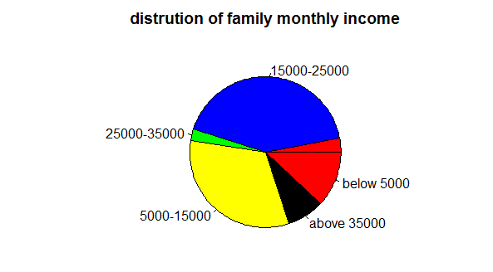

**Interpretation :-**From the above graph we see that maximum (43.3 %) respondent’s family monthly income lies between the range 15000-25000 and 33.5 % respondent’s family monthly income lies between the range 5000-15000 and 12.4 % respondent’s family monthly income lies between the range 0-5000 and 8.2 % respondent’s family monthly income lies above 35000and minimum(2.6 %) respondent’s family monthly income lies between the range 25000-35000.

**۞ TABLE 6: FREQUENCY TABLE & GRAPH REPRESENTING ACHIEVEMENT OF HIGHEST DEGREE OF THE RESPONDENTS’ PARENTS.**

|  |  |  |
| --- | --- | --- |
| **Statistics** | | |
| N | Valid | 199 |
| Missing | 1 |

|  |  |  |  |  |  |  |
| --- | --- | --- | --- | --- | --- | --- |
| Parent’s qualification | | Frequency | Percent | Valid Percent | Cumulative Percent | angle |
| Valid | High school | 51 | 25.5 | 25.6 | 25.6 | 92.16 |
| Intermediate | 45 | 22.5 | 22.6 | 48.2 | 81.36 |
| Graduation | 66 | 33.0 | 33.2 | 81.4 | 119.52 |
| Post Graduation | 24 | 12.0 | 12.1 | 93.5 | 43.56 |
| Ph.d. | 13 | 6.5 | 6.5 | 100.0 | 23.4 |
| Total | 199 | 99.5 | 100.0 |  | 360.0 |
| Missing | System | 1 | .5 |  |  |  |
| Total | | 200 | 100.0 |  |  |  |

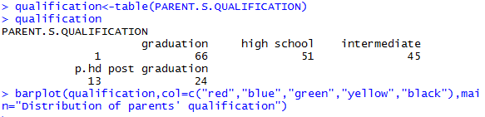

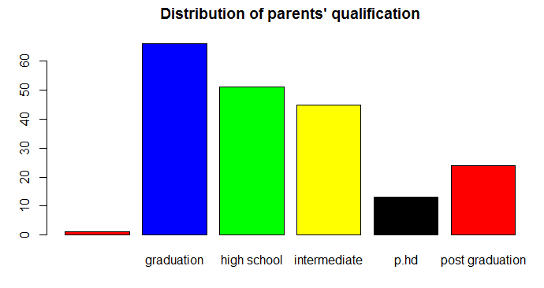



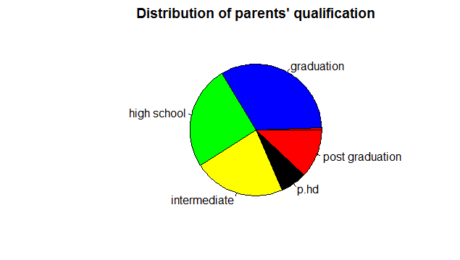

**Interpretation:-**Above graph show that maximum(33.2 %) parents of the respondents achieved the highest degree i.e. Graduation and second maximum(25.6 %) parents of the respondents achieved the highest degree i.e. high school and minimum (6.5 %) parents of the respondents achieved the highest degree i.e. Ph.d. whereas there are one missing data.

**۞ TABLE 7: FREQUENCY TABLE & GRAPH REPRESENTING MEDIUM OF STUDY AT HIGHER SECONDARY LEVEL OF THE RESPONDENTS.**

|  |  |  |
| --- | --- | --- |
| **Statistics** | | |
| N | Valid | 200 |
| Missing | 0 |

|  |  |  |  |  |  |  |
| --- | --- | --- | --- | --- | --- | --- |
| Medium of Study | | Frequency | Percent | Valid Percent | Cumulative Percent | angle |
| Valid | English | 88 | 44.0 | 44.0 | 44.0 | 158.4 |
| Hindi | 44 | 22.0 | 22.0 | 66.0 | 79.2 |
| Bengali | 68 | 34.0 | 34.0 | 100.0 | 122.4 |
| Total | 200 | 100.0 | 100.0 |  | 360.0 |

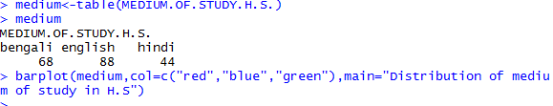

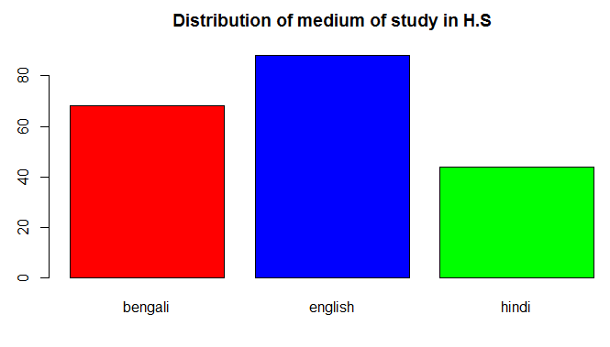



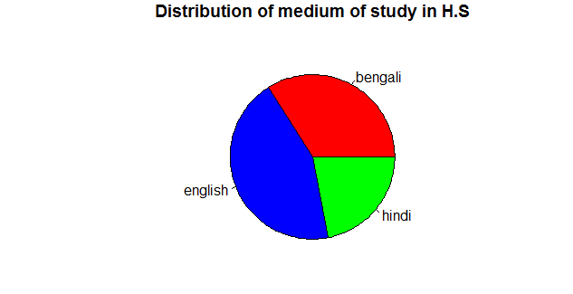

**Interpretation :-** Above graph show that maximum(44.0 %) respondents have English medium of study at Higher Secondary Level and 34.0 % respondents have Bengali medium of study at Higher Secondary Level and minimum (22.0 %) respondents have Hindi medium of study at Higher Secondary Level.

**۞ TABLE 8: FREQUENCY TABLE & GRAPH REPRESENTING LEVEL OF FACING PROBLEM IN THEIR STUDY DUE TO ENGLISH MEDIUM OF UNIVERSITY OF THE RESPONDENTS.**

|  |  |  |
| --- | --- | --- |
| **Statistics** | | |
| N | Valid | 200 |
| Missing | 0 |

|  |  |  |  |  |  |  |
| --- | --- | --- | --- | --- | --- | --- |
| Facing problem level | | Frequency | Percent | Valid Percent | Cumulative Percent | angle |
| Valid | Too much | 63 | 31.5 | 31.5 | 31.5 | 113.4 |
| Little bit | 44 | 22.0 | 22.0 | 53. | 79.2 |
| Not at all | 93 | 46.5 | 46.5 | 100.0 | 167.4 |
| Total | 200 | 100.0 | 100.0 |  | 360.0 |

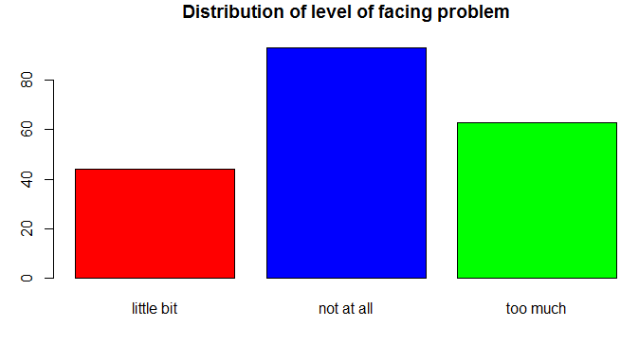

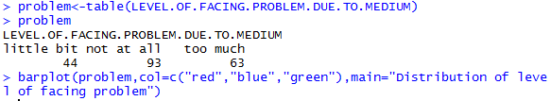



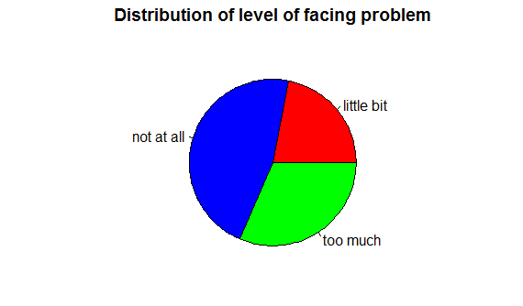

**Interpretation :-**From the above graph we see that maximum (46.5%) respondents have not faced any problem in their study due to English as the medium of study in the graduation and minimum (22.0 %) respondents have little bit problem in their study due to English as the medium of study in graduation.

**۞ TABLE 9: FREQUENCY TABLE & GRAPH REPRESENTING TEACHING METHOD FOLLOWED BY THE PROFESSORS.**

|  |  |  |
| --- | --- | --- |
| **Statistics** | | |
| N | Valid | 199 |
| Missing | 1 |

|  |  |  |  |  |  |  |
| --- | --- | --- | --- | --- | --- | --- |
| Methods of teaching | | Frequency | Percent | Valid Percent | Cumulative Percent | angle |
| Valid | Lecture method | 42 | 21.0 | 21.1 | 21.1 | 75.96 |
| Question-Answer method | 19 | 9.5 | 9.6 | 30.7 | 34.56 |
| Discussion method | 91 | 45.5 | 45.7 | 76.4 | 164.52 |
| Demonstration | 47 | 23.5 | 23.6 | 100.0 | 84.96 |
| Total | 199 | 99.5 | 100.0 |  | 360.0 |
| Missing | System | 1 | .5 |  |  |  |
| Total | | 200 | 100.0 |  |  |  |

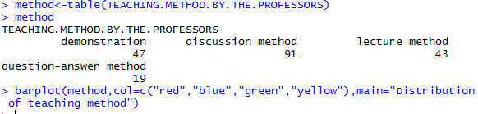

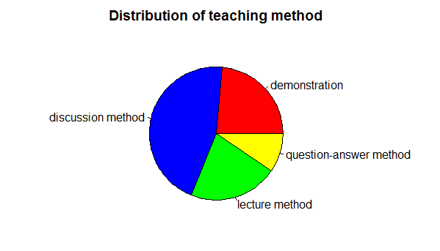



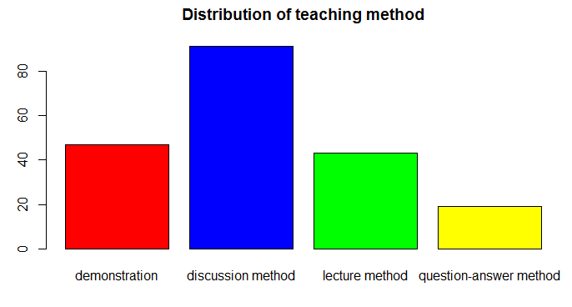

**Interpretation: -** From the above graph we see that maximum (45.7 %) respondents have selected Discussion method of teaching followed by our Professors during teaching and minimum (9.5 %) respondents have selected Question-Answer method of teaching followed by our Professors during teaching and 0.5% respondents are missing in our data.

**۞ TABLE 10: FREQUENCY TABLE & GRAPH REPRESENTING SATISFACTION LEVEL WITH THE TEACHING METHOD OF THE PROFESSORS BY THE RESPONDENTS.**

|  |  |  |
| --- | --- | --- |
| **Statistics** | | |
| N | Valid | 200 |
| Missing | 0 |

|  |  |  |  |  |  |  |
| --- | --- | --- | --- | --- | --- | --- |
| Satisfaction level | | Frequency | Percent | Valid Percent | Cumulative Percent | angle |
| Valid | Completely | 84 | 42.0 | 42.0 | 42.0 | 151.2 |
| Partially | 102 | 51.0 | 51.0 | 93.0 | 183.6 |
| Not at all | 14 | 7.0 | 7.0 | 100.0 | 25.2 |
| Total | 200 | 100.0 | 100.0 |  | 360.0 |

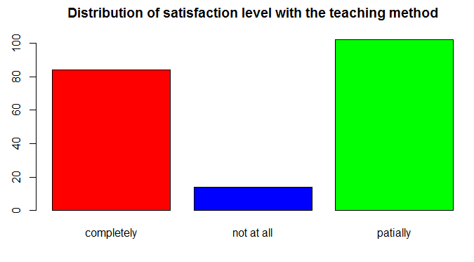

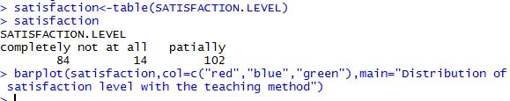



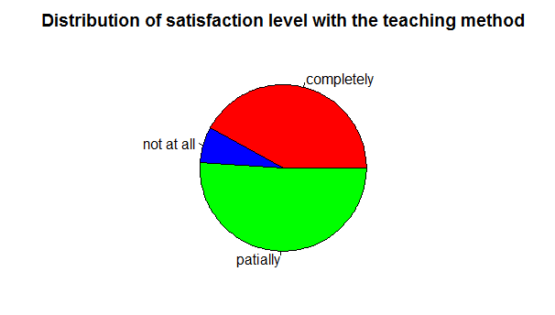

**Interpretation :-** Above graph show that maximum (51.0 %) respondents Partially satisfied with the teaching method adopted by our Professors and (42.0 %) respondents Completely satisfied with the teaching method adopted by our Professors and minimum(7.0) % respondents Not at all satisfied with the teaching method adopted by our Professors.

**۞ TABLE 11: FREQUENCY TABLE & GRAPH REPRESENTING SATISFACTION LEVEL WITH THE SINCERITY AND PUNCULITY OF THE PROFESSORS BY THE RESPONDENTS.**

|  |  |  |
| --- | --- | --- |
| **Statistics** | | |
| N | Valid | 200 |
| Missing | 0 |

|  |  |  |  |  |  |  |
| --- | --- | --- | --- | --- | --- | --- |
| Satisfaction level | | Frequency | Percent | Valid Percent | Cumulative Percent | angle |
| Valid | Completely | 61 | 30.5 | 30.5 | 30.5 | 109.8 |
| Partially | 92 | 46.0 | 46.0 | 76.5 | 165.6 |
| Not at all | 47 | 23.5 | 23.5 | 100.0 | 84.6 |
| Total | 200 | 100.0 | 100.0 |  | 360.0 |

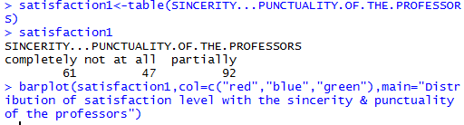

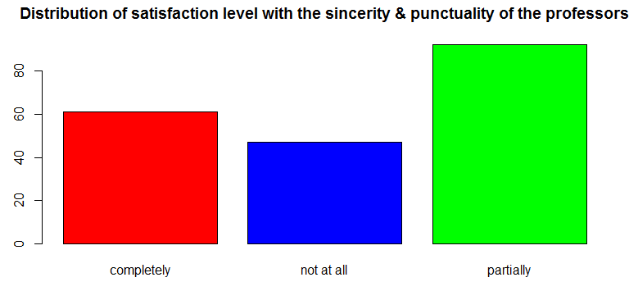



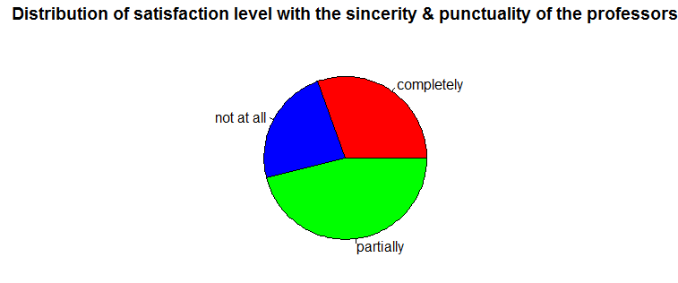

**Interpretation :-** Above graph show that maximum (46.0 %) respondents Partially satisfied with the sincerity and punctuality of Professors and (30.5 %) respondents Completely satisfied with the sincerity and punctuality of Professors and minimum (23.5 %) respondents Not at all satisfied with the the sincerity and punctuality of Professors.

**۞ TABLE 12: FREQUENCY TABLE & GRAPH REPRESENTING SATISFACTION LEVEL WITH THE EDUCATION THAT RECEIVED HERE BY THE RESPONDENTS.**

|  |  |  |
| --- | --- | --- |
| **Statistics** | | |
| N | Valid | 200 |
| Missing | 0 |

|  |  |  |  |  |  |  |
| --- | --- | --- | --- | --- | --- | --- |
| Satisfaction level | | Freque  ncy | Percent | Valid Percent | Cumulative Percent | angle |
| Valid | Very dissatisfied | 17 | 8.5 | 8.5 | 8.5 | 30.6 |
| Dissatisfied | 15 | 7.5 | 7.5 | 16.0 | 27.0 27.0 |
| Satisfied | 149 | 74.5 | 74.5 | 90.5 | 268.2 |
| Very Satisfied | 19 | 9.5 | 9.5 | 100.0 | 34.2 |
| Total | 200 | 100.0 | 100.0 |  | 360.0 |

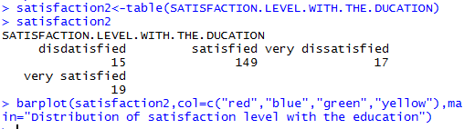

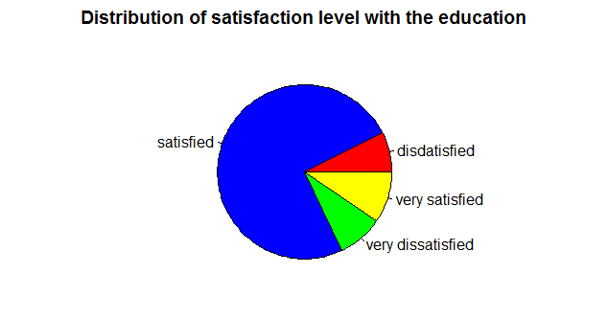



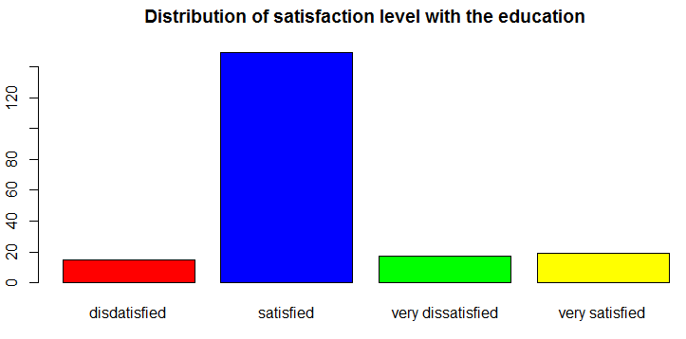

**Interpretation :-** From the above graph we see that maximum(74.5 %) respondents are Satisfied with the education that they received here and 8.5 % respondents are Very dissatisfied with the education that they received here and also 9.5 % respondents are Very Satisfied with the education that they received herebut minimum(7.5 %) respondents are Dissatisfied with the education that they received here.

**۞ TABLE 13: FREQUENCY TABLE & GRAPH REPRESENTING SOURCE OF MOTIVATION OF THE RESPONDENTS.**

|  |  |  |
| --- | --- | --- |
| **Statistics** | | |
| N | Valid | 198 |
| Missing | 2 |

|  |  |  |  |  |  |  |
| --- | --- | --- | --- | --- | --- | --- |
| Source of motivation | | Frequency | Percent | Valid Percent | Cumulative Percent | angle |
| Valid | Parents | 39 | 19.5 | 19.7 | 19.7 | 70.92 |
| Teacher | 56 | 28.0 | 28.3 | 48.0 | 101.88 |
| Experienced People | 53 | 26.5 | 26.8 | 74.8 | 96.48 |
| Self Motivated | 50 | 25.0 | 25.2 | 100.0 | 90.72 |
| Total | 198 | 99.0 | 100.0 |  | 360.0 |
| Missing | System | 2 | 1.0 |  |  |  |
| Total | | 200 | 100.0 |  |  |  |

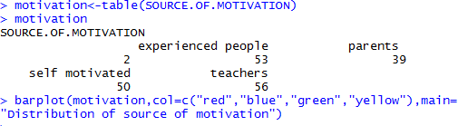



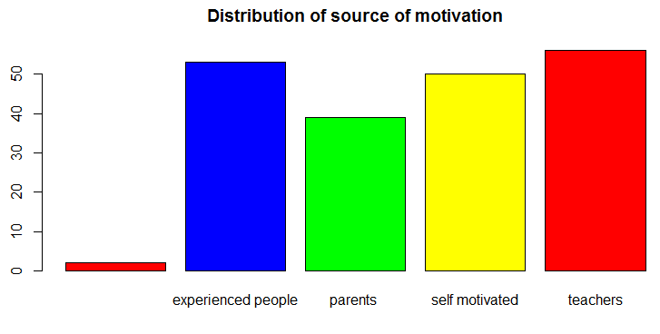

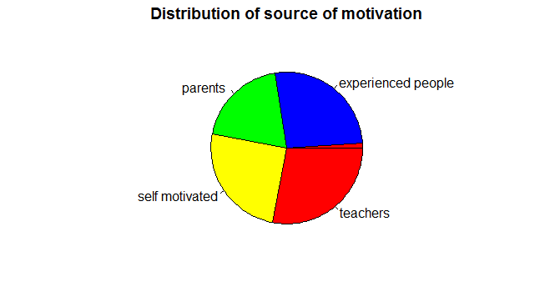

**Interpretation :-**Above graph show that maximum(28.3 %) respondents are motivated by their Teachers(Professors) and (26.8 %) respondents are motivated by the Experienced People and minimum (19.7 %) respondents are motivated by the Parents and (25.2 %) respondents are Self motivated but here (1.0 %) respondents are not replied this question i.e. we get the 1.0 % data are missing.

**۞ TABLE 14: FREQUENCY TABLE & GRAPH REPRESENTING HIGHER STUDY EXPECTATION.**

|  |  |  |
| --- | --- | --- |
| **Statistics** | | |
| N | Valid | 199 |
| Missing | 1 |

|  |  |  |  |  |  |  |
| --- | --- | --- | --- | --- | --- | --- |
| Field preference | | Frequency | Percent | Valid Percent | Cumulative Percent | Angle |
| Valid | MBA | 69 | 34.5 | 34.7 | 34.7 | 124.92 |
| masters | 125 | 62.5 | 62.8 | 97.5 | 226.08 |
| NO | 3 | 1.5 | 1.5 | 99.0 | 5.4 |
| Others | 2 | 1.0 | 1.0 | 100.0 | 3.6 |
| Total | 199 | 99.5 | 100.0 |  | 360.0 |
| Missing | System | 1 | .5 |  |  |  |
| Total | | 200 | 100.0 |  |  |  |

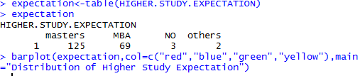

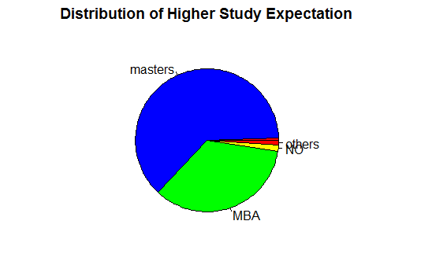



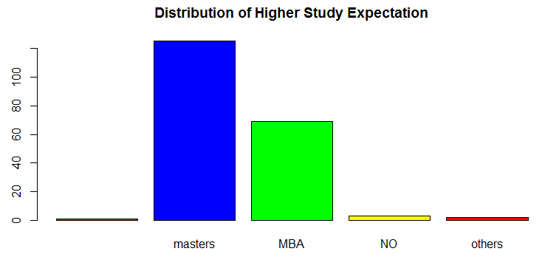

**Interpretation :-** Above graph show that maximum(62.8 %) respondents prefer masters just after completing their Graduation degree and (34.5 %) respondents prefer MBA just after completing their Graduation degree and (1.5 %) respondents prefer nothing just after completing their Graduation degree but here (0.5 %) respondents did not replied this question.

**۞ TABLE 15: FREQUENCY TABLE & GRAPH REPRESENTING PREFERABLE FIELD WORK IN FUTURE (IF THEY WANT TO CHANGE )OF THE RESPONDENTS.**

|  |  |  |
| --- | --- | --- |
| **Statistics** | | |
| N | Valid | 199 |
| Missing | 1 |

|  |  |  |  |  |  |  |
| --- | --- | --- | --- | --- | --- | --- |
| Field preference in future | | Frequency | Percent | Valid Percent | Cumulative Percent | Angle |
| Valid | service | 93 | 46.5 | 46.7 | 46.7 | 168.12 |
| Sports | 17 | 8.5 | 8.6 | 55.3 | 30.96 |
| Acting | 16 | 8.0 | 8.0 | 63.3 | 28.8 |
| Politics | 28 | 14.0 | 14.1 | 77.4 | 50.76 |
| Writing | 18 | 9.0 | 9.1 | 86.5 | 32.76 |
| Music | 15 | 7.5 | 7.5 | 94.0 | 27.0 |
| Others | 12 | 6.0 | 6.0 | 100.0 | 21.6 |
| Total | 199 | 99.5 | 100.0 |  | 360.0 |
| Missing | System | 1 | .5 |  |  |  |
| Total | | 200 | 100.0 |  |  |  |

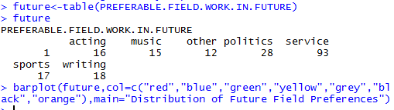



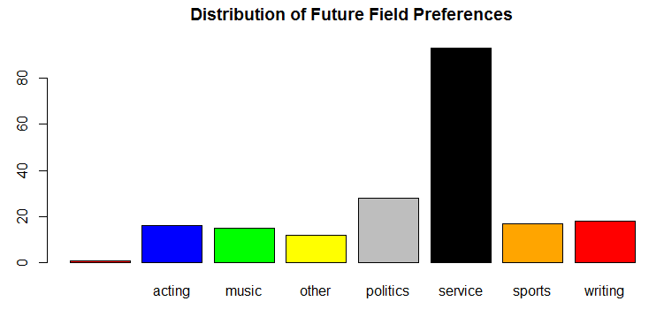

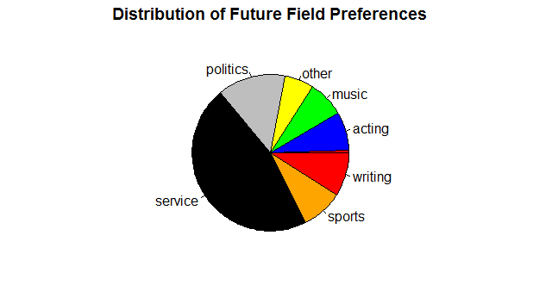

**Interpretation :-**Above graph show that maximum(46.5 %) respondents want to in service field work in future and (8.5 %) respondents want to go in Sports field in futureand (14.0 %) respondents want to go in Politics and 8.0 % respondents want to go in Acting field in future but also (0.5 %) respondents did not reply this question.

**۞TABLE 16: FREQUENCY TABLE & GRAPH REPRESENTING UNIVERSITY PREFERENCE FOR FUTURE STUDIES.**

|  |  |  |
| --- | --- | --- |
| **Statistics** | | |
| N | Valid | 200 |
| Missing | 0 |

|  |  |  |  |  |  |
| --- | --- | --- | --- | --- | --- |
| University preference | frequency | Percent | Valid percent | Cumulative percent | Angle |
| Same university | 116 | 58.00 | 58.00 | 58.00 | 208.8 |
| Other | 84 | 42.00 | 42.00 | 100.00 | 151.2 |
| Total | 200 | 100.00 | 100.00 |  | 360.0 |

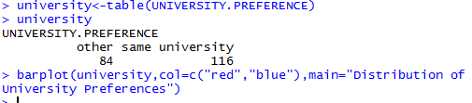

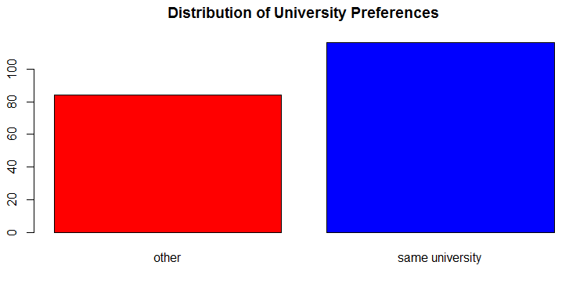



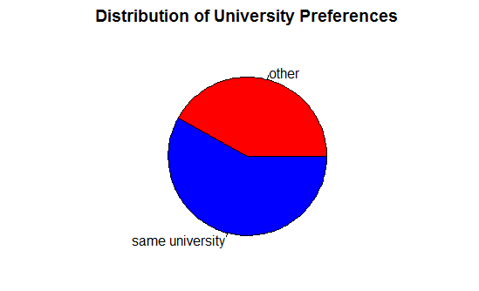

**Interpretation**:-from the graph we see that maximum (58.0%)respondents want to do their higher education from same(calcutta)university and 42% respondents wants to do it from other university.

**۞TABLE 17: FREQUENCY TABLE & GRAPH REPRESENTING CROSS TABLE BETWEEN HIGHER STUDY AND UNIVERSITY PREFERENCES OF THE Respondents.**

|  |  |  |  |  |
| --- | --- | --- | --- | --- |
| Higher Education | | University | | Total |
| Same University | Other University/ Institute |
|  | Masters | 115 | 10 | 125 |
| M.B.A. | 0 | 69 | 69 |
| Others | 0 | 5 | 5 |
| Total | | 115 | 84 | 199 |

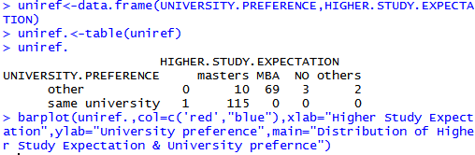

**Interpretation :-** From the above graph we can see that (55.3 %) respondents prefer the Higher Education field and (57.83 %) respondents want to pursue their Higher Education from the Other University/Institute and rest want to to pursue their Higher Education from the Same University and almost all Higher Education want to do from the Other University/Institute.

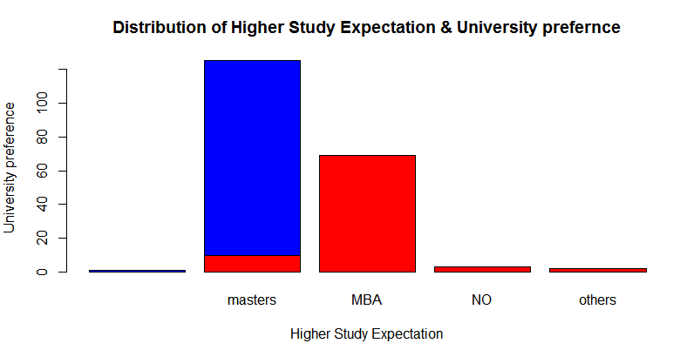

**۞TABLE 18: FREQUENCY TABLE & GRAPH REPRESENTING CROSS TABLE BETWEEN HIGHER STUDY AND GENDER OF THE RESPONDENTS.**

|  |  |  |  |  |
| --- | --- | --- | --- | --- |
| Higher Education | | Gender | | Total |
| Male | Female |
|  | Masters | 87 | 38 | 125 |
| M.B.A. | 25 | 44 | 69 |
| Others | 1 | 4 | 5 |
| Total | | 113 | 86 | 199 |

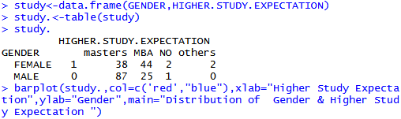

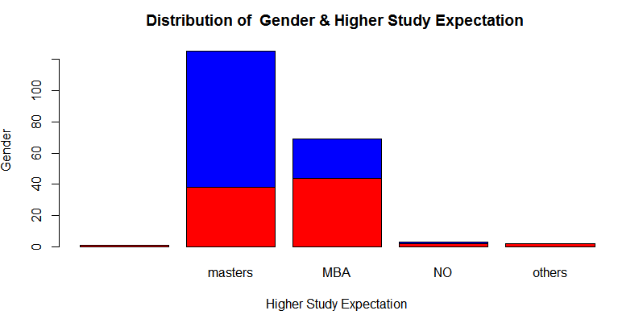

**Interpretation :-** From the above graph we can see that maximum(77.38 %) respondents male & female in which male proportion is higher than female want to do M.Sc. after B.Sc. and (10.71 %) respondetns male & female want to do M.B.A. in which proportion of female is higher than male respondents and rest respondents are want to do Other Higher Education.

**۞TABLE 19: FREQUENCY TABLE & GRAPH REPRESENTING CROSS TABLE BETWEEN RESIDENCY OF THE RESPONDENTS AND THEIR PARENTS QUALIFICATION.**

|  |  |  |  |  |  |  |  |
| --- | --- | --- | --- | --- | --- | --- | --- |
| Residency | | Highest Degree | | | | | Total |
| High school | Intermediate | Graduation | Post Graduation | Ph.d. |
|  | Rural | 36 | 37 | 0 | 0 | 0 | 73 |
| Urban | 15 | 8 | 66 | 24 | 13 | 126 |
| Total | | 51 | 45 | 66 | 24 | 13 | 199 |

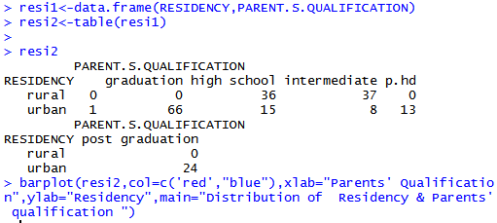

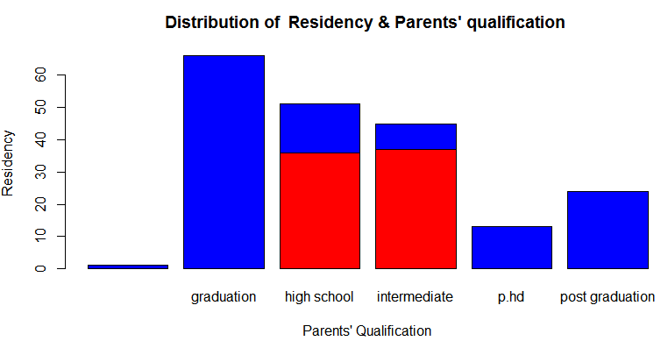

**Interpretation :-** From the above graph we can see that maximum( 47.61%) respondents’ parents have the Graduation degree that belongs to Rural area and rest (44.18 %) respondents’ parents have the Graduation degree that belongs to Urban area.

**۞ TABLE 20: FREQUENCY TABLE & GRAPH REPRESENTING CROSS TABLE BETWEEN RESIDENCY AND MEDIUM OF STUDY AT HIGHER SECONDARY LEVEL OF THE RESPONDENTS.**

|  |  |  |  |  |  |
| --- | --- | --- | --- | --- | --- |
| Residency | | Medium of Study | | | Total |
| English | Hindi | Bengali |
|  | Rural | 0 | 31 | 42 | 73 |
| Urban | 88 | 13 | 26 | 127 |
| Total | | 88 | 44 | 68 | 200 |

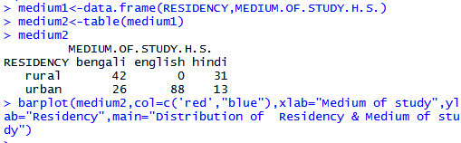

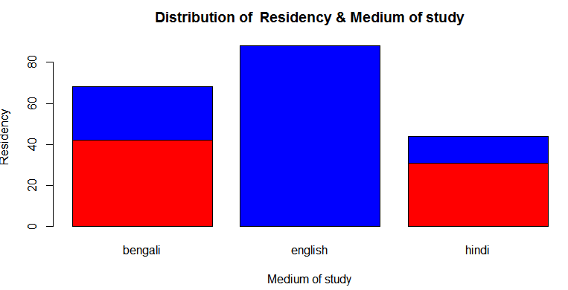

**Interpretation :-** From the above graph we can see that maximum( 57.14 %) respondents have English medium of study at higher secondary level that belongs to Rural area and maximum(71.26 %) respondents have English medium of study at higher secondary level that belongs to Urban area.

**۞ TABLE 21: FREQUENCY TABLE & GRAPH REPRESENTING CROSS TABLE BETWEEN RESIDENCY AND FACING PROBLEM IN THEIR STUDY DUE TO ENGLISH MEDIUM OF UNIVERSITY OF THE RESPONDENTS.**

|  |  |  |  |  |  |
| --- | --- | --- | --- | --- | --- |
| Residency | | Level of facing problem | | | Total |
| Too much | Little bit | Not at all |
|  | Rural | 53 | 20 | 0 | 73 |
| Urban | 10 | 24 | 93 | 127 |
| Total | | 63 | 44 | 93 | 200 |

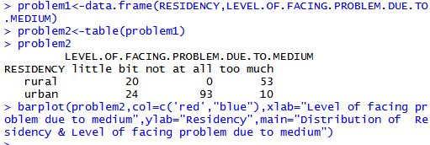

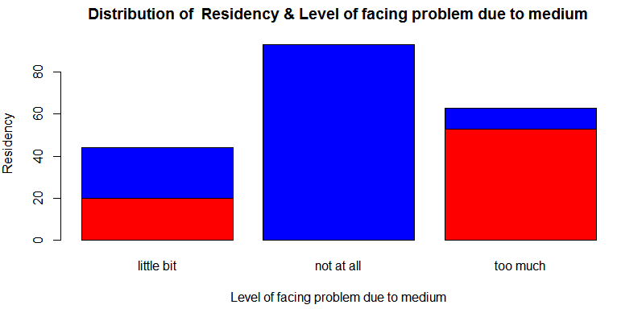

**Interpretation :- A**bove graph show that maximum(58.73 %) respondents have not faced any problem in their study due to English as the medium of study in the University that belongs to the Rural area and maximum(78.16 %) respondents have not faced any problem in their study due to English as the medium of study in the University that belongs to the Urban area.

**۞ TABLE 22: FREQUENCY TABLE & GRAPH REPRESENTING CROSS TABLE BETWEEN RESIDENCY AND FIELD PREFERENCES IN FUTURE OF THE RESPONDENTS.**

|  |  |  |  |  |
| --- | --- | --- | --- | --- |
| Field preferences | | Residency | | Total |
| Rural | Urban |
|  | Service | 22 | 71 | 93 |
| Acting | 16 | 0 | 16 |
| sports | 16 | 1 | 17 |
| politics | 9 | 19 | 28 |
|  | writing | 5 | 13 | 18 |
|  | Music | 0 | 13 | 13 |
|  | Others | 5 | 7 | 12 |
| Total | | 73 | 124 | 197 |

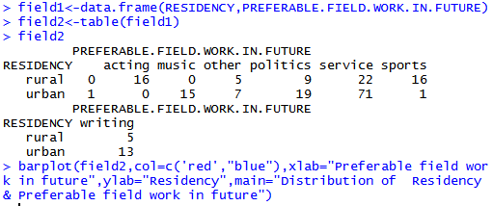

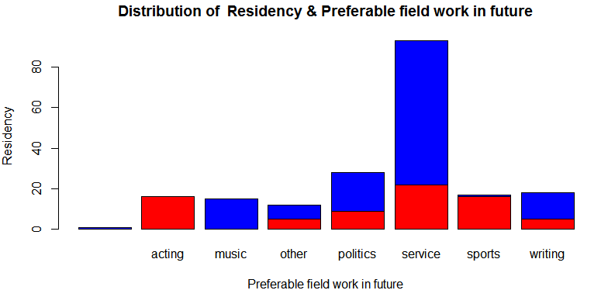

**Interpretation :-** Above graph show that maximum(39.76 %) respondents select the Higher Education as the field preferences just after completing their B.Sc. Degree that belongs to Rural area and maximum(60.24 %) respondents select the Higher Education as the field preferences just after completing their B.Sc. Degree that belongs to Urban area.

**۞ TABLE 23: FREQUENCY TABLE & GRAPH REPRESENTING CROSS TABLE BETWEEN GENDER AND HONOURS SUBJECT OF THE RESPONDENTS.**

|  |  |  |  |  |
| --- | --- | --- | --- | --- |
| Honours subject | | Gender | | Total |
| Male | Female |
|  | Physics | 10 | 8 | 18 |
| Chemistry | 13 | 10 | 23 |
| mathematics | 24 | 8 | 32 |
| Zoology | 10 | 9 | 19 |
|  | Botany | 15 | 13 | 28 |
|  | Computer science | 13 | 0 | 13 |
|  | Statistics | 28 | 8 | 36 |
|  | Geography | 0 | 14 | 14 |
|  | Geology | 0 | 17 | 17 |
| Total | | 113 | 87 | 200 |

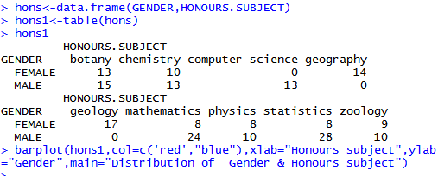

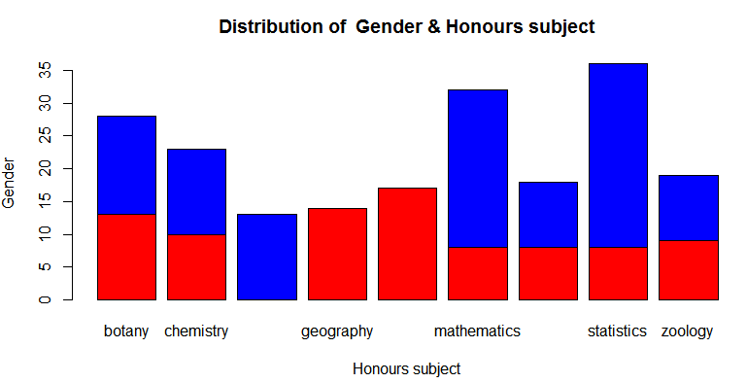

**Interpretation :-** Above graph show that maximum no. of females have selected the Job & Civil Services field preference and no any females select the other field preference and maximum no. of males have selected the Higher Education field preference.

**۞ TABLE 24: FREQUENCY TABLE & GRAPH REPRESENTING CROSS TABLE BETWEEN PLACE OF RESIDENCY AND FAMILY MONTHLY INCOME OF THE RESPONDENTS.**

|  |  |  |  |  |  |  |
| --- | --- | --- | --- | --- | --- | --- |
| Residency | Family Monthly Income | | | | |  |
| 0-5000 | 5000-15000 | 15000-25000 | 25000-35000 | Above 35000 | Total |
| Rural | 24 | 41 | 8 | 0 | 0 | 73 |
| Urban | 0 | 24 | 76 | 5 | 16 | 123 |
| Total | 24 | 65 | 84 | 5 | 16 | 196 |

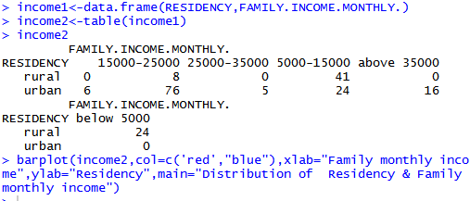

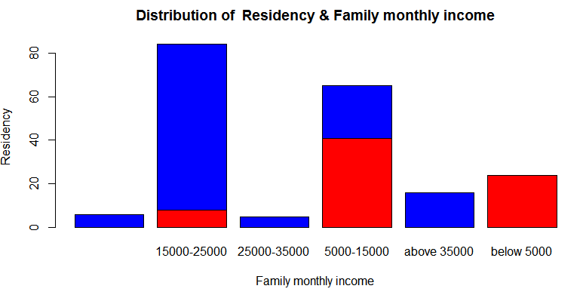

Interpretation: From the above graph we can show that maximum(56.16 %) rural residents earn 5000-15000 rupees monthly and maximum(61.79 %)urban residents earn 15000-25000 rupees per month.

**۞TABLE 25: FREQUENCY TABLE & GRAPH REPRESENTING CROSS TABLE BETWEEN HONOURS SUBJECT AND TEACHING METHOD FOLLOWED BY THE PROFESSORS.**

|  |  |  |  |  |  |  |  |  |  |  |
| --- | --- | --- | --- | --- | --- | --- | --- | --- | --- | --- |
| Teaching method | Honours subject | | | | | | | | | |
| ph | ch | Math | Zoo | Bot | c.s | stat | Geog | geol | Total |
| Lecture method | 0 | 1 | 3 | 5 | 6 | 0 | 1 | 10 | 17 | 43 |
| Question-answer method | 0 | 0 | 19 | 0 | 0 | 0 | 0 | 0 | 0 | 19 |
| Discussion method | 12 | 16 | 10 | 4 | 4 | 6 | 35 | 4 | 0 | 91 |
| Demonstration | 6 | 6 | 0 | 10 | 18 | 7 | 0 | 0 | 0 | 47 |
| Total | 18 | 23 | 32 | 29 | 28 | 13 | 36 | 14 | 17 | 200 |

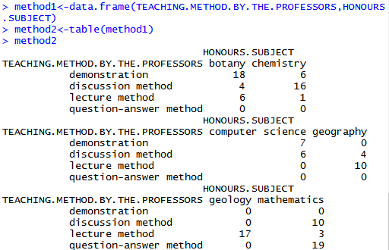

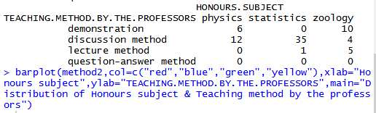

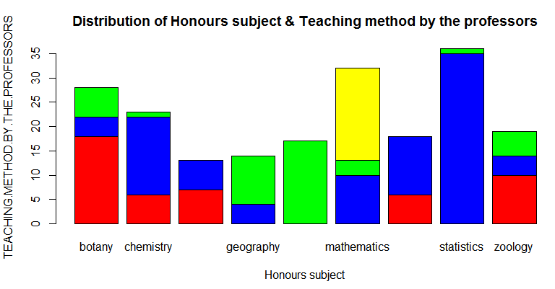

**Interpretation**: From the above graph we can show that maximum (39.53%) respondents from geology are teached with lectural method and maximum (100%)respondents from mathematics are teached with question-answer method and maximum(38.46%)respondents from statistics are teached with discussion method and maximum (38.30%)respondents from zoology are teached with Demonstration method.

۞**TABLE 26: FREQUENCY TABLE & GRAPH REPRESENTING CROSS TABLE BETWEEN TEACHING METHOD FOLLOWED BY THE PROFESSORS AND SATISFACTION LEVEL WITH THE TEACHING METHOD OF THE PROFESSORS BY THE RESPONDENTS.**

|  |  |  |  |  |  |
| --- | --- | --- | --- | --- | --- |
| Teaching method | Satisfaction level | | | |  |
| completely | partially | Not at all | Total | |
| Lectural method | 7 | 27 | 9 | 43 | |
| Question-answer method | 3 | 16 | 0 | 19 | |
| Discussion method | 32 | 54 | 5 | 91 | |
| demonstration | 42 | 5 | 0 | 47 | |
| Total | 84 | 102 | 14 | 200 | |

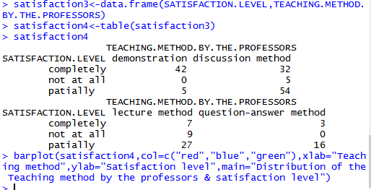

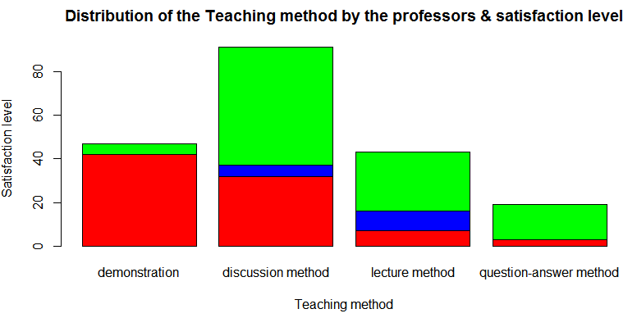

**Interpretation**:From the above graph we can see that maximum(62.79%)respondents are partially satisfied with the lectural(teaching)method and maximum(84.21%)respondents are partially satisfied with the question-answer (teaching)method and maximum(59.34%)respondents are partially satisfied with the Discussion(teaching)method and maximum(89.36%)respondents are completely satisfied with the Demonstration method.

۞**TABLE 27: FREQUENCY TABLE & GRAPH REPRESENTING CROSS TABLE BETWEEN HONOURS SUBJECT AND HIGHER STUDY EXPECTATION OF THE RESPONDENTS.**

|  |  |  |  |  |  |
| --- | --- | --- | --- | --- | --- |
| Honours subject | Higher Study Expectation | | | | Total |
| MBA | Masters | NO | Other |
| Physics | 0 | 18 | 0 | 0 | 18 |
| Chemistry | 4 | 19 | 0 | 0 | 23 |
| Mathematics | 4 | 28 | 0 | 0 | 32 |
| Zoology | 14 | 5 | 0 | 0 | 19 |
| Botany | 23 | 0 | 3 | 2 | 28 |
| c.s | 0 | 13 | 0 | 0 | 13 |
| Statistics | 0 | 35 | 0 | 0 | 35 |
| Geography | 7 | 7 | 0 | 0 | 14 |
| Geology | 17 | 0 | 0 | 0 | 17 |
| Total | 69 | 125 | 3 | 2 | 199 |

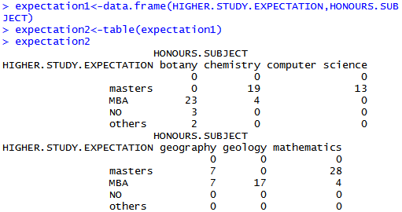

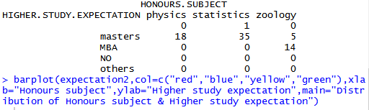

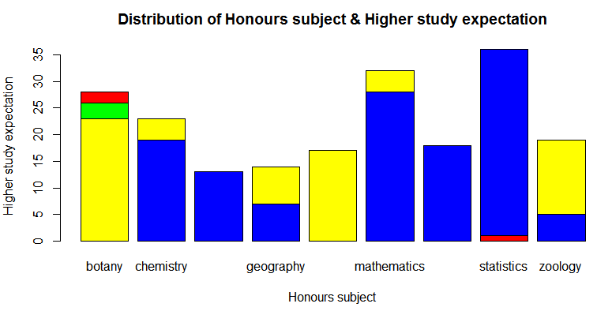

**Interpretation**:From the above graph we can see that maximum(100%)physics hons. Students are interested to doing masters and maximum(82.60%)chemistry students are interested to doing masters and maximum(73.68%)zoology sudents are interested to doing MBA and maximum(82.14%)botany students are interested to doing their MBA and maximum(87.5%)mathematics students are interested to doing their masters and maximum(100%)computer science students are interested to doing their masters and maximum(100%)statistics students are interested to doing their masters and 50%geography students are interested to doing their masters and 50% are interested in MBA and maximum(100%)geology students are interested to doing their MBA.

**۞TABLE28: FREQUENCY TABLE & GRAPH REPRESENTING CROSS TABLE BETWEEN PLACE OF RESIDENCY AND HIGHER STUDY EXPECTATION OF THE RESPONDENTS.**

|  |  |  |  |  |  |
| --- | --- | --- | --- | --- | --- |
| Residency | Higher Study Expectation | | | | |
| MBA | Masters | No | Other | Total |
| Rural | 52 | 21 | 0 | 0 | 73 |
| Urban | 17 | 104 | 3 | 2 | 126 |
| Total | 69 | 125 | 3 | 2 | 199 |

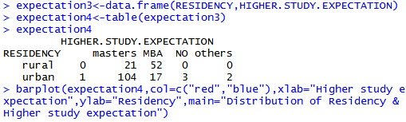

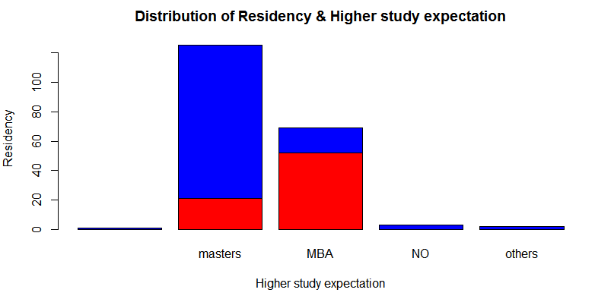

**Interpretation:**From the above graph we can see that maximum(71.23%)students coming from rural area are interested to doing MBA and maximum(82.54%)students from urban area are interested to doing masters.

**۞TABLE29: FREQUENCY TABLE 7 GRAPH REPRESENTING CROSS TABLE BETWEEN FAMILY MONTHLY INCOME AND HIGHER STUDY EXPECTATION OF THE RESPONDENTS.**

|  |  |  |  |  |  |
| --- | --- | --- | --- | --- | --- |
| Family income | Higher Study Expectation | | | | Total |
| MBA | Masters | NO | Other |
| 0-5000 | 24 | 0 | 0 | 0 | 24 |
| 5000-15000 | 33 | 28 | 2 | 2 | 65 |
| 15000-25000 | 7 | 75 | 1 | 0 | 83 |
| 25000-35000 | 5 | 0 | 0 | 0 | 5 |
| Above 35000 | 0 | 16 | 0 | 0 | 16 |
| Total | 69 | 119 | 3 | 2 | 193 |
|  |  |  |  |  |  |

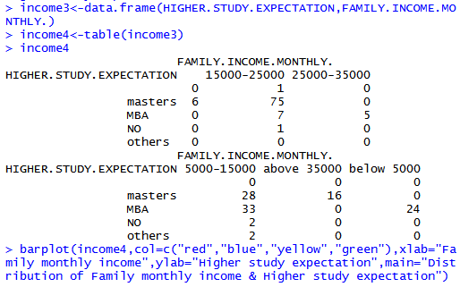

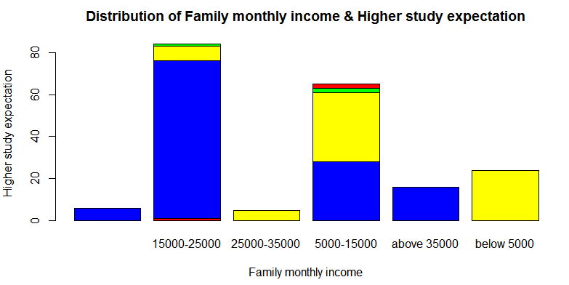

**Interpretation**: From the above graph we can see that maximum(47.82%)students who wish to complete MBA have family income in the range 5000-15000and maximum(63.03%)students who wish to complete their masters have family income 15000-25000.

**۞CONCEPT OF CHI SQUARE TEST**

I have used chi square test of independency of attribute for bivariate data .This test is usually used when the sample size is large.

1. Null Hypothesis for the test in Residency of the respondents & preferable future field work of the respondents is

Ho: Residency of the respondents does not affects the future field preferences of the respondents.

H1:Residency of the respondents affects the future field preferences of the respondents.

**Here we use 7*2 contingency table .**

**Contingency table**:-

|  |  |  |  |  |  |
| --- | --- | --- | --- | --- | --- |
|  | | | Residency | | Total |
| Rural | Urban |
| Preferable field work in future | Service | Observed frequency | 22 | 71 | 93 |
| Expected frequency | 34.5 | 58.5 | 93.0 |
| Sports | Observed frequency | 16 | 1 | 17 |
| Expected frequency | 6.3 | 10.7 | 17.0 |
| Acting | Observed frequency | 16 | 0 | 16 |
| Expected frequency | 5.9 | 10.1 | 16.0 |
| Writing | Observed frequency | 5 | 13 | 18 |
| Expected frequency | 6.7 | 11.3 | 18.0 |
| Politics | Observed frequency | 9 | 19 | 28 |
| Expected frequency | 10.4 | 17.6 | 28.0 |
| Music | Observed frequency | 0 | 13 | 13 |
| Expected frequency | 4.8 | 8.2 | 13.0 |
| Other | Observed frequency | 5 | 7 | 12 |
| Expected frequency | 4.4 | 7.6 | 12.0 |
| Total | | Observed frequency | 73 | 124 | 197 |
| Expected frequency | 73.0 | 124.0 | 197.0 |



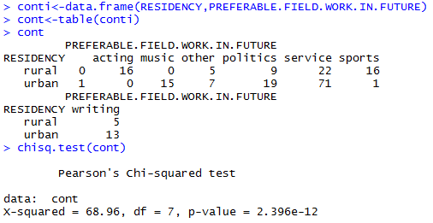

Since χ2cal = ∑(oij-fij)^2/fij

Hence χ2cal= 68.96

And χ2 tab = 6.345811 at 5% level of significance and 7 d. f.

Now since χ2cal>χ2 tab , Hence we reject the Null Hypothesis at 5% level of significance.

Thus, we conclude that Residency of the respondents affetcs the future field preferences of the respondents.

2.Null Hypothesis for the test in Honours subject and Future Field Preference of the respondents is

Ho:Honours subject does not affect Future Field Preference of the respondents.

H1:Honours subject affects Future Field Preference of the respondents.

Here we use 7*9 contingency table.

Contingency table:-

|  |  |  |  |  |  |  |  |  |  |  |  |
| --- | --- | --- | --- | --- | --- | --- | --- | --- | --- | --- | --- |
| Field preference |  | Honours subject | | | | | | | | | total |
| phy | chem | Math | zoo | bot | c.s | stat | geog | geol |
| Service | 0.f | 10 | 22 | 19 | 0 | 7 | 0 | 28 | 7 | 0 | 93 |
| e.f | 8.0 | 10.8 | 14.9 | 8.9 | 13.1 | 6.1 | 16.8 | 6.5 | 7.9 | 93.0 |
| Sports | o.f | 0 | 0 | 0 | 14 | 3 | 0 | 0 | 0 | 0 | 17 |
| e.f | 1.5 | 2.0 | 2.7 | 1.6 | 2.4 | 1.1 | 3.1 | 1.2 | 1.5 | 17.0 |
| Acting | o.f | 0 | 0 | 0 | 5 | 3 | 0 | 0 | 0 | 8 | 16 |
| e.f | 1.4 | 1.8 | 2.6 | 1.5 | 2.2 | 1.1 | 2.9 | 1.1 | 1.4 | 16.0 |
| Writing | o.f | 0 | 1 | 0 | 0 | 3 | 0 | 4 | 5 | 5 | 18 |
| e.f | 1.5 | 2.1 | 2.9 | 1.7 | 2.5 | 1.2 | 3.3 | 1.3 | 1.5 | 18.0 |
| Politics | o.f | 0 | 0 | 10 | 0 | 12 | 2 | 0 | 0 | 4 | 28 |
| e.f | 2.4 | 3.2 | 4.5 | 2.7 | 4.0 | 1.8 | 5.0 | 2.0 | 2.4 | 28.0 |
| Music | o.f | 0 | 0 | 0 | 0 | 0 | 11 | 4 | 0 | 0 | 15 |
| e.f | 1.3 | 1.7 | 2.4 | 1.4 | 2.1 | 1.0 | 2.7 | 1.1 | 1.3 | 15.0 |
| Other | o.f | 7 | 0 | 3 | 0 | 0 | 0 | 0 | 2 | 0 | 12 |
| e.f | 1.0 | 1.4 | 1.9 | 1.2 | 1.7 | 0.8 | 2.2 | 0.8 | 1.0 | 12.0 |
| Total | o.f | 17 | 23 | 32 | 19 | 28 | 13 | 36 | 14 | 17 | 199 |
| e.f | 17.0 | 23..0 | 31.9 | 19.0 | 28.0 | 13.0 | 36.0 | 14.0 | 17.0 | 199.0 |

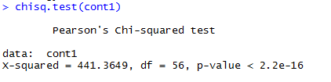

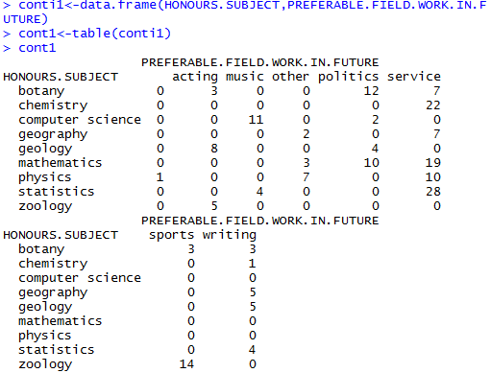



Since χ2cal = ∑(oij-fij)^2/fij

Hence χ2cal= 441.3649 Andχ2 tab = 74.46832 at 5% level of significance and 56 d. f. Now since χ2cal>χ2 tab  , Hence we reject the Null Hypothesis at 5% level of significance.

Thus, we conclude that Residency of the Honours subject affetcs the Future field preferences of the respondents

3.Null Hypothesis for the test in Honours subject and Higher study Expectation of the respondents is

Ho:Honours subject does not affect Higher study Expectation of the respondents.

H1:Honours subject affects Higher study Expectation of the respondents.

Here we use 9*4 contingency table.

Contingency table:

|  |  |  |  |  |  |  |
| --- | --- | --- | --- | --- | --- | --- |
| Hons. subject | Higher Study Expectation | | | | | total |
|  | MBA | Masters | No | Other |
| Phy | o.f | 0 | 18 | 0 | 0 | 18 |
| e.f | 6.2 | 11.3 | 0.3 | 0.2 | 18.0 |
| Chem | o.f | 4 | 19 | 0 | 0 | 23 |
|  | e.f | 8.0 | 14.4 | 0.4 | 0.2 | 23.0 |
| Math | o.f | 4 | 28 | 0 | 0 | 32 |
| e.f | 11.1 | 20.1 | 0.5 | 0.3 | 32.0 |
| Zoo | o.f | 14 | 5 | 0 | 0 | 19 |
| e.f | 6.6 | 11.9 | 0.3 | 0.2 | 19.0 |
| Bot | o.f | 23 | 0 | 3 | 2 | 28 |
| e.f | 9.7 | 17.6 | 0.4 | 0.3 | 28.0 |
| c.s | o.f | 0 | 13 | 0 | 0 | 13 |
| e.f | 4.5 | 8.2 | 0.2 | 0.1 | 13.0 |
| Stat | o.f | 0 | 35 | 0 | 0 | 35 |
| e.f | 12.1 | 22.0 | 0.5 | 0.4 | 35.0 |
| Geog | o.f | 7 | 7 | 0 | 0 | 14 |
| e.f | 4.9 | 8.8 | 0.2 | 0.1 | 14.0 |
| Geol | o.f | 17 | 0 | 0 | 0 | 17 |
| e.f | 5.9 | 10.7 | 0.2 | 0.2 | 17.0 |
| Total | o.f | 69 | 125 | 3 | 2 | 199 |
| e.f | 69.0 | 125.0 | 3.0 | 2.0 | 199.0 |

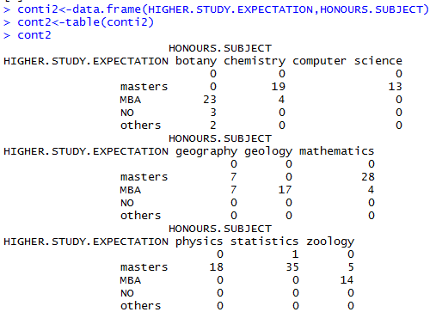

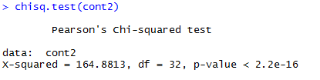



Since χ2cal = ∑(oij-fij)^2/fij

Hence χ2cal= 164.8813

And χ2 tab = 46.19426 at 5% level of significance and 32 d. f.

Now since χ2cal>χ2 tab  , Hence we reject the Null Hypothesis at 5% level of significance.

Thus, we conclude that Residency of the Honours subject affetcs the Higher study expectation of the respondents

4.Null Hypothesis for the test in Family Monthly Income and Higher study Expectation of the respondents is

Ho: Family Monthly Income does not affect Higher study Expectation of the respondents.

H1:Family Monthly Income affects Higher study Expectation of the respondents.

Here we use 5*4 contingency table.

Contingency table:

|  |  |  |  |  |  |  |
| --- | --- | --- | --- | --- | --- | --- |
| Family income | Higher Study Expectation | | | | | total |
|  | MBA | Masters | No | other |  |
| 0-5000 | o.f | 24 | 0 | 0 | 0 | 24 |
| e.f | 8.6 | 14.8 | 0.4 | 0.2 | 24.0 |
| 5000-15000 | o.f | 33 | 28 | 2 | 2 | 65 |
| e.f | 23.2 | 40.1 | 1.0 | 0.7 | 65.0 |
| 15000-25000 | o.f | 7 | 75 | 1 | 0 | 83 |
| e.f | 29.7 | 51.2 | 1.3 | 0.8 | 83.0 |
| 25000-35000 | o.f | 5 | 0 | 0 | 0 | 5 |
| e.f | 1.8 | 3.0 | 0.1 | 0.1 | 5.0 |
| Above 35000 | o.f | 0 | 16 | 0 | 0 | 16 |
| e.f | 5.7 | 9.9 | 0.2 | 0.2 | 16.0 |
| Total | o.f | 69 | 119 | 3 | 2 | 193 |
| e.f | 69.0 | 119.0 | 3.0 | 2.0 | 193.0 |

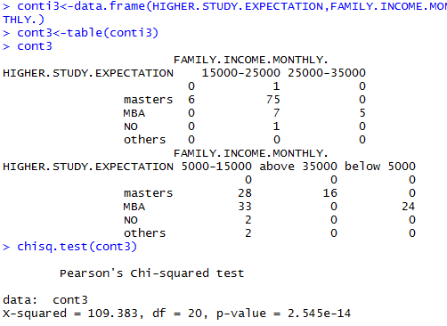



Since χ2cal = ∑(oij-fij)^2/fij

Hence χ2cal=109.383

And χ2 tab =31.41043 at 5% level of significance and 32 d. f.

Now since χ2cal>χ2 tab  , Hence we reject the Null Hypothesis at 5% level of significance.

Thus, we conclude that Residency of the family income affetcs the Higher study expectation of the respondents

5. Null Hypothesis for the test in Gender and Year of enrollment in graduation of the respondents.

H0:Gender of the respondents does not affect year of enrollment in graduation of the respondents.

H1: Gender of the respondents affects year of enrollment in graduation of the respondents.

Here we use 2*3 contingency table.

Contingency table:

|  |  |  |  |  |  |
| --- | --- | --- | --- | --- | --- |
| Gender | Year of enrollment in Graduation | | | | Total |
|  | 2012 | 2013 | 2014 |
| Male | o.f | 10 | 18 | 85 | 113 |
|  | e.f | 9.0 | 16.4 | 87.6 | 113.0 |
| Female | o.f | 6 | 11 | 70 | 87 |
| e.f | 7.0 | 12.6 | 67.4 | 87.0 |
| Total | o.f | 16 | 29 | 155 | 200 |
| e.f | 16.0 | 29.0 | 155.0 | 200.0 |

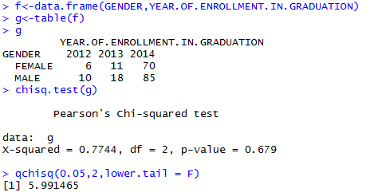

Since χ2cal = ∑(oij-fij)^2/fij

Hence χ2cal=0.7744

And χ2 tab =5.991465 at 5% level of significance and 2 d. f.

Now since χ2cal<χ2 tab  , Hence we may accept the Null Hypothesis at 5% level of significance.

Thus, we conclude that Gender of the respondents does not affect the Year of enrollment in Graduation of the respondents.

6. Null Hypothesis for the test in University preference and Year of enrollment in graduation of the respondents.

Ho:Year of enrollment the respondents does not affect University preference of the respondents.

H1:Year of enrollment the respondents affects University preference of the respondents .

Here we use 3*2 contingency table.

Contingency table:

|  |  |  |  |  |
| --- | --- | --- | --- | --- |
| year | University preference | | | Total |
|  | Other | Same |
| 2012 | o.f | 6 | 10 | 16 |
| e.f | 6.7 | 9.3 | 16.0 |
| 2013 | o.f | 14 | 15 | 29 |
| e.f | 12.2 | 16.8 | 29.0 |
| 2014 | o.f | 64 | 91 | 155 |
| e.f | 65.1 | 89.9 | 155.0 |
| total | o.f | 84 | 116 | 200 |
| e.f | 84.0 | 116.0 | 200.0 |

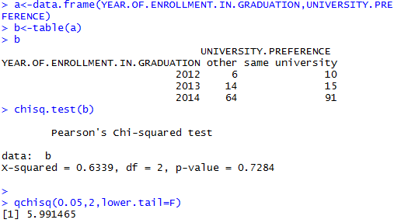

Since χ2cal = ∑(oij-fij)^2/fij

Hence χ2cal=0.6339

And χ2 tab =5.991465 at 5% level of significance and 2 d. f.

Now since χ2cal<χ2 tab  , Hence we may accept the Null Hypothesis at 5% level of significance.

Thus, we conclude that Year of enrollment of the respondents does not affect the University preference of the respondents

7. Null Hypothesis for the test in Year of enrollment in graduation of the respondents and satisfaction level with the education.

H0:Year of enrollment the respondents does not affect satisfaction level with the education of the respondents.

H1:Year of enrollment the respondents affects satisfaction level with the education of the respondents .

Here we use 3*4 contingency table.

contingency table:

|  |  |  |  |  |  |  |
| --- | --- | --- | --- | --- | --- | --- |
| year | Satisfaction level with the education | | | | | Total |
|  | dissatisfied | satisfied | Very dissatisfied | Very satisfied |
| 2012 | o.f | 0 | 11 | 3 | 2 | 16 |
|  | e.f | 1.2 | 11.9 | 1.4 | 1.5 | 16.0 |
| 2013 | o.f | 0 | 26 | 3 | 0 | 29 |
|  | e.f | 2.2 | 21.6 | 2.4 | 2.8 | 29.0 |
| 2014 | o.f | 15 | 112 | 11 | 17 | 155 |
|  | e.f | 11.6 | 115.5 | 13.2 | 14.7 | 155.0 |
| total | o.f | 15 | 149 | 17 | 19 | 200 |
|  | e.f | 15.0 | 149.0 | 17.0 | 19.0 | 200.0 |

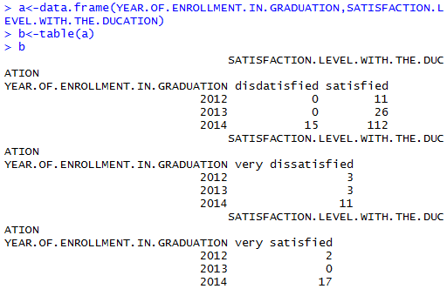

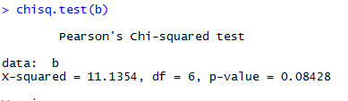



Since χ2cal = ∑(oij-fij)^2/fij

Hence χ2cal=11.1354

And χ2 tab =12.59159 at 5% level of significance and 6 d. f.

Now since χ2cal<χ2 tab  , Hence we may accept the Null Hypothesis at 5% level of significance.

Thus, we conclude that Year of enrollment of the respondents does not affect satisfaction level with the education received by the respondents.

**CONCLUSION**

From my entire work of project we got several points about the Teaching quality of Professors and Field preference of respondents in future. These are the following points:-

* Maximum(51.0 %)people are Partially Satisfied with the teaching method adopted by our Teacher/Professors.
* Maximum(46.0 %)people are Partially Satisfied with the sincerity and punctuality of Teacher/Professors.
* Maximum(74.5 %) people are Satisfied with the education that they received here.
* On the basis of Survey we can say that maximum(62.8 %) people want to complete their masters just after completing their Graduation.
* Almost Male(77.0 %) and Female(51.16 %) person are equally want to complete masters just after completing their Graduation.
* Maximum(46.5 %)people want to do service job in their Future.
* Maximum(24.78 %)male want to study statistics honours subject and maximum(19.54 %)female want to study geology honours subject.
* Maximum(57.99 %) people want to continue their Higher education from same(Calcutta) University.
* On the basis of Survey we can see that maximum(28.3 %) people are motivated by the Teachers(Professors)for their field work in future.
* On the basis of Survey we can conclude that Residency of the respondents is dependent to the field preferences of the respondents in future.
* On the basis of survey we can conclude that Gender of the Respondents does not affect Year of enrollment in graduation of the respondents.
* On the basis of survey we can conclude that year of enrollment in graduation does not affect university preference of the respondents.
* On the basis of survey we can conclude that year of enrollment does not affect satisfaction level with the education received by the respondents.
* By the Ranking of Professions preferences we can conclude that most preferable profession is service job and Research and development job & acting are least preferable profession.

**FIELD EXPERIENCES**

The success of any survey depends upon the quality and honesty of the surveyor who collects the basic data. The accuracy of the data collected and co-operation of the person depends upon the ability of the investigator in expressing the aim of the survey.

This project provided me practical application of the theory of Statistics, We have learnt so far, in our post graduate program. And it was full of exciting experience

Keeping this view I have tried my best to get reliable data and information. I came across a variety of experiences during the project work.

The project work is completely new, learning and interesting experience for me. I think it was great golden opportunity for me to learn something new for real life project.

**DIFFICULTIES**

It is the fact that whenever a new work starts there are some difficulties in completing the work. A brief description of the difficulties which I faced while making survey and analyze the data is given below:-

* For the completion of project work, I have to start it first and to begin I had to make the questionnaire. The basic need for questionnaire is to have the complete knowledge of the given topic for this I approach my supervisor and as I thought he helped a lot. He gave me the basic knowledge of the topic and helped me in the preparation of questionnaire.
* distributed the questionnaire to candidates so that they could fill it but when the time came to collect it, I found that some forms were not filled, many time when I went to collect the forms they were not present or busy in their own work. Because of this I had to run to their doors many times.
* Once the data was collected I thought that my project was fairly complete but it was only a beginning. Once the data was collected I had to feed it in new statistical software called R, about which I did not have any knowledge. Again I approached my supervisor for help and he gave me the basic knowledge of R. Because of him I was able to enter the data and make graphs and tables.
* Last not the least I also faced difficulty to get the printouts as well as for binding. Every project has difficulties and to overcome it I had to work together. In this project many times I went blank and did not know how to act but then I approached my supervisor, project mates and my friends. Every time they help me out and at last my project got completed. So this project is not actually mine but is of each and every person who helped me. So I greatly thank everyone for their contribution in my project.

**LIMITATIONS**

1) The first limitation of my project report is the sample size which is one hundred and fifty in number. This number of sample size is not sufficient as compare to the total population.

2) The second limitation of my project is that all the analysis and findings are based only on responses of the respondents, without checking its correction.

3) The third limitation of my project is that most of respondent did not want to reveal the actual information.

4) The fourth limitation of my project is the time limitation, which was also one of the constraints in my whole world.

5) The last but not least limitation of my project report is that the whole data is collected from 3rd year Graduation students of few colleges of Calcutta university only.

**QUESTIONNAIRE**

**An Opinion Survey on Graduation 3rd Year College Students of Calcutta University regarding “Teaching Quality & Future Working Field Preferences”**

NAME : GENDER:

CLASS : SUBJECT:

RESIDENCE : COLLEGE NAME:

RURAL:

URBAN:

Q1. Which year have you enrolled for graduation?

2012: 2013: 2014: 2011:

Q2. What is your Family Income (Monthly)?

<5000 5000-15000 15000-25000 25000-35000 >35000

Q3. Qualification of Parents

Intermediate High School Graduation Masters

Doctorate

Q4. Medium of study in HS level

Hindi English Bengali Others

Q4.Feeling any problem due to the medium(English) in graduation?

Too Much Little bit Not at all

Q5.Teaching method in the class?

Lecture Question-Answer Discussion Demonstration

**QUESTIONAIRE**

Q6.Satisfaction Level with the teaching method.

Completely Partially Not At All

Q7.Sincerity & Punctuality of the Professors.

Completely Partially Not At All

Q8.Source of motivation for the students career.

Teachers Parents Self Motivated Experienced People

Q9. Which Working field would you like to choose in your future?

…………………………………………………………………………………………….

Q10. Would you like to go for Higher Studies?

Yes No

If Yes, then

Masters(In own field) MBA Research Others

Q11. Which University would you prefer to complete your higher studies?

Same University Other University

Q12. Satisfaction Level with the education System received here?

Satisfied

Dissatisfied

Very much Satisfied

Very much Dissatisfied

**BIBLIOGRAPHY**

**1**) **BOOKS FOR REFERENCES:-**

* Goon. A.M., Gupta, M.K., Das Gupta. B. (1991):- Fundamentals of Statistics. Vol.-1. World Press, Calcutta.
* Sukhatme, P.V., Sukhatme, B.V., Sukhatme, S. and Ashok. C (1984):- Sampling Theory of Surveys with Applications. Indian Society of Agricultural Statistics.
* Goon. A.M., Gupta, M.K., Das Gupta. B. (1986):- Fundamentals of Statistics. Vol.-2. World Press, Calcutta.
* Gupta, S.C., Kapoor, V. K.:-Fundamentals of Mathematical Statistic

**2) INTERNET SITE FOR REFERENCES:-**

[www.google.com](http://www.google.com/)

